
Tribhuvan University
Faculty of Humanities and Social Sciences

“Gym Membership and Class Management System”

A PROJECT REPORT
Submitted to
Department of Computer Application
Thames International College
In partial fulfillment of the requirements for the Bachelors of Computer Application

Submitted By:
Pranav Gurung  BCA 4th Semester  Registration No: 6-2-450-65-2022  Symbol No: 45002103  2025/03/10 | Ipsit Shrestha  BCA 4th Semester  Registration No: 6-2-450-58-2022  Symbol No: 45002096  2025/03/10
Under the Supervision of:
Mr. Aashutosh Poudel


Tribhuwan University
Faculty of Humanities and Social Sciences
Thames International College

Supervisor’s Recommendation

I hereby recommend that this project prepared under my supervision by Ipsit Shrestha and entitled “Gym Membership and Class Management System” in partial fulfillment of the requirements for the degree of Bachelor of Computer Application is recommended for the final evaluation.

____________________
Mr. Aashutosh Poudel
SUPERVISOR
BCA Department
Thames International College



Tribhuwan University
Faculty of Humanities and Social Sciences
Thames International College

LETTER OF APPROVAL

This is to certify that this project prepared by Ipsit Shresta and Pranav Gurung entitled “Gym Membership and Class Management System” in partial fulfillment of the requirements for the degree of Bachelor in Computer Application has been evaluated. In our opinion it is satisfactory in terms of scope and quality as a project for the required degree.
SIGNATURE of Supervisor  __________________  Mr. Aashutosh Poudel  Supervisor  Thames International College | SIGNATURE of HOD/Co-ordinator  __________________  Mr. Surendra Malla  Head of Department  Thames International College
SIGNATURE of Internal Examiner  __________________  Mr. Pesal Rai  Faculty at SOIT  Thames International College | SIGNATURE of External Examiner  __________________  Mr. Ramesh Singh Saud  Padma Kanya Multiple College

ABSTRACT
The Gym Membership and Class Management System (GMCS) is designed to optimize gym operations, enhancing efficiency and user experience for both members and administrators. This system enhances key processes such as membership management, class scheduling, attendance tracking, and progress monitoring, replacing traditional manual methods prone to inefficiencies and errors.
By integrating digital solutions, GMCS provides a user-friendly platform where members can easily register, renew memberships, book classes, and track their fitness journey. At the same time, administrators and trainers can efficiently manage member data, schedules, and payment records, reducing administrative workload and improving operational accuracy.
The project aims to address challenges in gym management by offering a secure, scalable, and cost-effective solution that enhances overall user engagement. Through systematic research, design, development, and testing, the GMCS ensures a smooth experience for gym staff and members, promoting an organized and modernized approach to fitness center management.
Keyword: Java Swing, Database, Class Member Registration.

ACKNOWLEDGEMENT
The completion of this project marks a significant milestone in our academic journey, and we would like to take this opportunity to express our heartfelt gratitude to everyone who contributed to its success. The development of the Gym Membership and Class Management System (GMCS) was both a challenging and rewarding experience, made possible through the guidance, support, and encouragement of many individuals.
First and foremost, we extend our sincere appreciation to our supervisor, Mr. Aashutosh Poudel, whose invaluable feedback, mentorship, and constant motivation played a crucial role in refining our project
A special note of thanks goes to our lecturer, Mr. Avinash Maskey, for his continuous guidance in troubleshooting technical challenges and his insightful contributions to the documentation process, which helped us maintain academic standards.
Additionally, we acknowledge the unwavering support of our classmates, whose encouragement, friendly competition, and collaborative efforts kept us inspired throughout this journey. Lastly, we extend our gratitude to Tribhuvan University and Thames International College for providing us with this opportunity to apply our knowledge in a real-world scenario, allowing us to expand our skills and practical understanding.
Ipsit Shrestha
Pranav Gurung

TABLE OF CONTENTS

Supervisor’s Recommendation i
LETTER OF APPROVAL ii
ABSTRACT iii
ACKNOWLEDGEMENT iv
LIST OF ABBREVIATIONS vii
LIST OF FIGURES viii
LIST OF TABLES ix
CHAPTER 1: INTRODUCTION 1
1.1 Introduction 1
1.2 Problem Statement 1
1.3 Objectives 2
1.4 Scopes and Limitations: 2
1.4.1 Scopes: 2
1.4.2 Limitations: 3
1.5 Report Organization 3
CHAPTER 2: BACKGROUND STUDY AND LITERATURE REVIEW 5
2.1 Background Study 5
2.2 LITERATURE REVIEW 5
CHAPTER 3: SYSTEM ANALYSIS AND DESIGN 7
3.1 System Analysis 7
3.1.1 Requirement Analysis 7
3.1.2 Feasibility Analysis 10
3.1.3 Data Modelling 12
3.1.4 Process Modelling 14
3.2 System Design 15
3.2.1 Architectural Design 15
3.2.2 Database Schema Design 18
3.2.3 Interface Design 19
3.2.4 Physical DFD 21
Chapter 4: Implementation and Testing 22
4.1 Implementation: 22
4.1.1 Tools Used 22
4.1.2 Implementation details of modules 22
4.2 Testing: 26
4.2.1 Test Cases for Unit Testing 26
4.2.2 Test Cases for System Testing 28
Chapter 5: Conclusion 30
5.1. Lesson Learnt / Outcome 30
5.2. Conclusion 31
5.3. Future Recommendations 31
REFERENCES 33
Appendix 34

LIST OF ABBREVIATIONS

GMCS Gym Membership and Class Management System
HOD Head of Department
SQL Structured Query Language
UI User Interface

LIST OF FIGURES

Figure 3.1: Waterfall Model for Gym Membership and Class Management System 7
Figure 3.2 Use Case Diagram of Gym Membership and Class Management System 9
Figure 3.3 Gantt chart for Gym Membership and Class Management System 11
Figure 3.4 E-R Diagram of Gym Membership and Class Management System 12
Figure 3.5 Context Level Diagram of Gym Membership and Class Management System 14
Figure 3.6 DFD Level 0 of Gym Membership and Class Management System 15
Figure 3.7 Architecture Design of Gym Membership and Class Management System 17
Figure 3.8 Architecture Design of Gym Membership and Class Management System 18
Figure 3.9 Overall System Interface of Gym Membership and Class Management System 20
Figure 3.10 Physical DFD Level 0 of Gym Membership and Class Management System 21

LIST OF TABLES

Table 3.1 Gantt chart Table for Gym Membership and Class Management System 11
Table 4.1 Login Functionality Test Cases 26
Table 4.2 Member Dashboard Viewing Test Cases 27
Table 4.3 Get Trainer Test Cases 27
Table 4.4 User Management Test Cases 27
Table 4.5 Progress Tracking Test Cases 28
Table 4.6 Test Cases For System Testing 29

CHAPTER 1: INTRODUCTION

1.1 Introduction
Gym Membership and Class Management System (GMCS) is aimed at making gym memberships and activities efficient and easier for the users. This system serves as a comprehensive tool to help many fitness centers in handling membership data and schedules of their clients efficiently, while also tracking the individuals progress, attendances, member engagement and the overall experience for gym members.

By digitalizing the membership process, the system will simplify the daily operations of fitness facilities, from organizing class schedules, tracking attendance and monitoring the progress of each individual. This will provide a user-friendly interface that allows users to easily track attendance, monitor progress, schedule classes, and many more, while also enabling gym administrators to manage all the related tasks with much efficiency and accuracy.

Through this project, we aim to provide a solution that not only improves operational efficiency for fitness centers but also enhances member satisfaction by offering high quality and modernized membership management experience.

1.2 Problem Statement
Many gyms and fitness centers face significant challenges in managing their memberships efficiently. The current reliance on manual processes for tracking member data, such as attendance, payment information, and renewals, often results in administrative inefficiencies and a higher risk of errors. Additionally, the lack of a centralized system for storing and organizing member information makes it difficult for staff to quickly access and retrieve necessary data, causing delays and potential dissatisfaction among members. Another key issue is the inability to monitor and track members’ progress effectively, which can negatively impact the member’s experience. Furthermore, the process of managing payments and subscription renewals is often complex, leading to missed payments, billing errors, and confusion for both gym staff and members. Many gyms also fail to provide a smooth user experience, leaving members frustrated when trying to sign up, renew memberships, or track their fitness progress. Tracking individuals’ progress without any tools is a problem as well as there isn't any proper way of knowing if any trainer has prior appointment or not which can be frustrating for the gym members. A modernized gym management system that can improve operational efficiency and enhance the overall member experience.

1.3 Objectives
The objectives of this app are as follows:
- To digitalize gym membership and progress tracking
- To optimize the administrative tasks of managing a gym
1.4 Scopes and Limitations:

1.4.1 Scopes:
The Gym Membership and Class Management System (GMCS) is designed to enhance the efficiency of gym operations by automating key processes such as membership management, class scheduling, and progress tracking. The system aims to provide a user-friendly interface for both gym members and administrators, offering the following functionalities:
- Membership Management: Enables gym members to register, renew, and manage their memberships online.
- Class and Trainer Scheduling: Allows members to book classes and personal training sessions while helping trainers manage their schedules.
- Attendance Tracking: Provides an automated system for tracking member attendance and participation in gym activities.
- Progress Monitoring: Facilitates members in tracking their fitness progress and performance over time.
- Payment Management: Helps administrators handle subscription payments, renewals efficiently.

1.4.2 Limitations:
While GMCS offers several advantages, it also has some limitations:
- Local Server Dependency: The system relies on a local server for data storage and processing, meaning it cannot be accessed remotely unless additional network configurations are implemented. This may limit accessibility for gym administrators and members outside the gym premises.
- Limited Customization: The initial version may not accommodate all specific business needs, requiring future modifications or expansions.
- Hardware Requirements: The system depends on compatible devices for smooth operation.
- Security Concerns: While the system employs security measures, data breaches remain a potential risk if users do not follow proper security protocols.
- Payment Gateway Restrictions: Integration with third-party payment gateways may be limited to specific providers, affecting payment options for users.
- Scalability Issues: In its initial version, the system is designed for small to mid-sized gyms and may require further optimization for larger fitness chains.

1.5 Report Organization
This project report is organized as follows:
Preliminary Section: This section consists of Title page, Abstract, Acknowledgement, Table of Content, List of Figures, List of Tables and List of Abbreviations.
Introduction Section: In this section, Overview, Problem Statement, Objectives, and Scope and Limitations of the project are discussed.
Background Study and Literature Review Section: In this section, the Background study and the Literature review of the project are discussed.
System Analysis Section: Requirement analysis (Functional and Non-Functional requirements), Feasibility analysis (technical, operational, economic, schedule), Data modelling, Process modelling and System design makes up the bulk of the section.
Implementation and Testing: Implementation and Testing are discussed in this section.
Conclusion and Future Recommendation Section: Outcome, Conclusion and Future recommendations are discussed in this section.

CHAPTER 2: BACKGROUND STUDY AND LITERATURE REVIEW

2.1 Background Study
It has been found that many existing gym management systems lack comprehensive features for effectively tracking fitness progress. This gap often prevents users from focusing on specific training and exercises that would optimize muscle development and overall gym progress. GMCS assists the members in keeping track of progress, which in turn helps the user to focus on certain training and exercises which are beneficial for better muscle development and gym progress. The trainers are also able to give feedback and give suggestions to their client after their individual sessions and help them if any needed. Different websites and systems have different features which are very beneficial for the user, though all of those features are not available in a single website or system, that is where GMCS helps the user to make it efficient as well as easier to access all those features in a single system for the ease of usability. The GMCS assists in managing a gym's operations, including overseeing member activities, class schedules, and progress tracking. Traditionally, gym staff have had to handle these tasks manually, which may lead to issues such as missed appointments, error in membership management and difficulties in tracking member progress. GMCS automates these processes, which reduces the gym staff and members’ workload and providing a seamless experience for the users. By digitizing these tasks, GMCS ensures that all necessary operations are handled efficiently, making it easier for staff to keep records updated and for members to stay engaged with their fitness journey.

2.2 LITERATURE REVIEW
Before getting into the development of the system, we thoroughly studied the current practices and available resources within the fitness industry. This study was contributory in creating the roadmap for the system's development. We observed that many gyms still rely on manual paper-work processes to manage memberships, schedules, and payments, which can lead to inefficiencies and errors. We also explored how different gyms currently handle these tasks and identified the areas where the GMCS could offer meaningful improvements.
We also studied existing systems that serve similar purposes as the system. Among them, GymMaster is a gym management software designed to make it easy to maintain detailed records of members and their memberships, book classes and trainers, process and track sales, and communicate with the right members at the right time. It makes it easier for members to book into classes or personal training sessions, update their profile, check in, view workouts and visitation [1]
Zoho Gym Management is another gym management software that allows the management of client memberships and packages, schedule training sessions, track member attendance, and seamlessly process payments. Their gym management software is designed to make it easy to manage and administrate fitness clubs of all sizes. This app is ideal for creating schedules for clients and ensuring that trainers are available. It can track the number of members in various classes and analyze the busiest times of the day to manage trainers' schedules more efficiently. Opening new sessions, monitoring staff availability, rescheduling classes can be done with their simple drag and drop interface. [2]
Zen Planner is also a system with member attendance and skill tracking, interactive online calendar, reminder and email templates, they have everything it takes to grow and maintain the fitness community members have created. It has a helpful dashboard and reporting tools keep you informed as to how users business is doing and one can instantly access membership data from anywhere. It focuses on helping fitness businesses manage memberships, schedule classes, and automate administrative tasks. [3]
Mindbody is also another system that has features like appointment scheduling, membership management, staff management, client app for booking, automated marketing tools, and payment processing. It has a comprehensive suite of tools that serve fitness centers, wellness businesses, and gyms, along with robust marketing and client engagement features. It has a user-friendly interface, strong customer support, and integrations with third-party apps. [4]

CHAPTER 3: SYSTEM ANALYSIS AND DESIGN

3.1 System Analysis
This system is designed with a series of processes starting with research, planning, design, development, testing and debugging. During research, all the functional and nonfunctional requirements are analyzed, and system is developed according to the requirement then designing of the system is carried out. After the planning and design process, coding and development part is started then after integrating the system there is testing of the system. If the testing is positive then the system is implemented otherwise some debugging is done and system comes to operation.

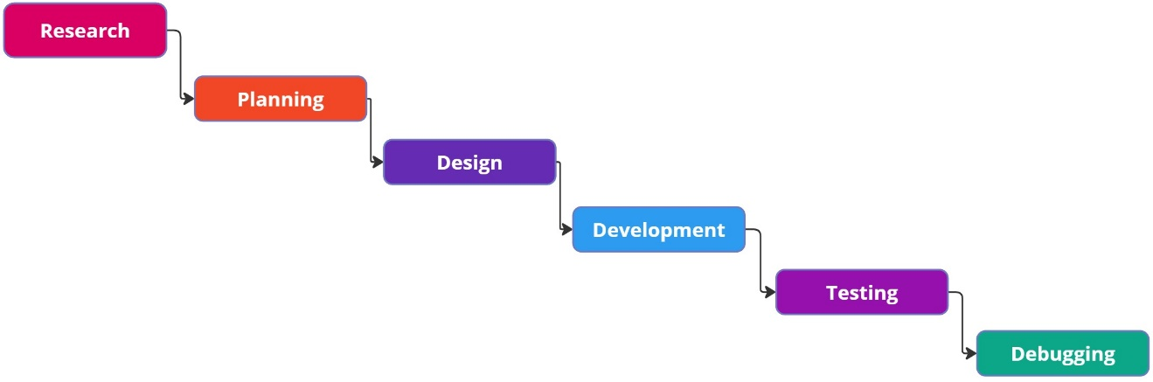

Fig 3.1: Waterfall Model for Gym Membership and Class Management System

3.1.1 Requirement Analysis
The requirements are to be collected before starting projects' development life cycle. To design and develop systems, functional as well as non-functional requirement of the system has been studied.

  - Functional Requirement
Different functional requirements of the system have been identified and have been listed below:

For Administration:
- The admin should be able to create, edit and delete gym membership plans.
- The admin should be able to create and manage class schedules, including assigning trainers and defining time slots.
- The admin should be able to create member and trainer account..
- The admin should be able to browse available classes, view class schedules, and register for classes.
- The admin should be able to track their workout progress, and monitor their progress.

For Trainers:
- Trainers should be able to create and manage their profiles, including uploading qualifications, schedules, and specialty areas.
- Trainers should be able to view their assigned classes, member enrollments, and attendance records.
- Trainers should be able to track individual member progress.
- Trainers should be able to manage their personal schedules and update their availability for training sessions or classes.

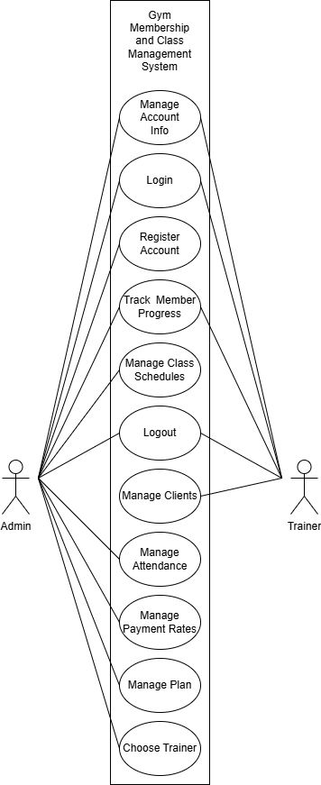

Figure 3.2: Use Case Diagram of Gym Membership and Class Management System
  - Non Functional Requirement
Different non-functional requirements of the system have been identified and have been listed below:
- Security: The system is secure from outside attacks as only authorized users and admins are allowed to access the data. This system also uses at least 8-character passwords for security. Different validation processes are used.
- Performance: The performance of the system is fast and accurate as in this system database is normalized so it provide fast operations.

3.1.2 Feasibility Analysis
The feasibility study concluded that the project is able to be implemented to success as it was carefully planned.

- Technical Feasibility Study
The system is technically feasible as the requirement for the development of the system is easily accessible. The necessary hardware and software required for the development and implementation of the system is available. The basic programming language which is suitable for project is available and the libraries required for project is capable of achieving the result that we are aiming for. All the resources need for development of the system are already available.

- Operational Feasibility Study
The system is easy to operate with the basic knowledge of computer and internet, and well trained manpower is not necessary. Users can also easily access the system as it is user friendly in many aspects with good User Interface (UI). This system include all the requirements used for the gym management system and this system is completely operational and can be successfully implemented and the administration can easily use this system as it is user-friendly.

- Economic Feasibility Study
The system is economically feasible and cost effective. As all the tools and resources required are either open sources or free. After the completion of the system, the organization didn't need to deploy any new hardware and software as the required software and hardware already exist.

- Schedule Feasibility
The system can be completed within the scheduled time.

Table 3.1: Gantt chart Table for Gym Membership and Class Management System
Task Name | Duration
Research | 1 Week
Planning | 1 Week
Designing | 1 Week
Development | 6 Weeks
Testing | 3 Weeks
Debugging | 1 Week
Documentation | 12 Weeks

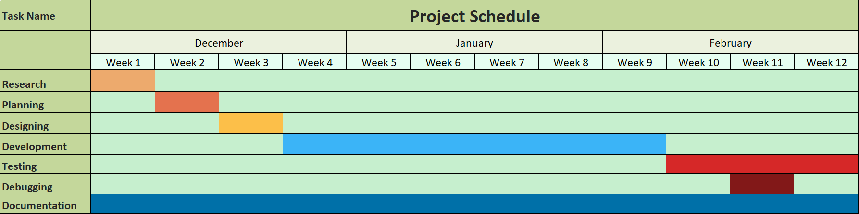

Fig 3.3: Gantt chart for Gym Membership and Class Management System

3.1.3 Data Modelling

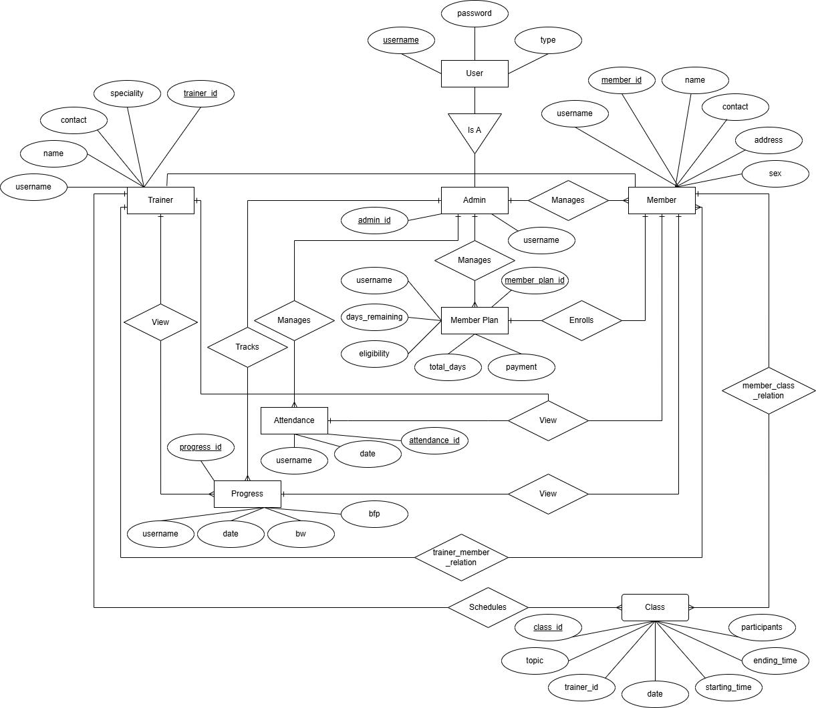

Fig 3.4: E-R Diagram of Gym Membership and Class Management System

Entities & Attributes
- User
  - Attributes: username, password, type
  - General entity for all users (Admin, Trainer, Member)
- Admin
  - Attributes: admin_id
  - Manages Member and Member Plan
- Trainer
  - Attributes: trainer_id, name, contact, specialty
  - Can view Member information and track their progress
- Member
  - Attributes: member_id, name, contact, address, sex
  - Can enroll in Member Plan
  - Has a relation with Class (member_class_relation)
- Member Plan
  - Attributes: member_plan_id, username, days_remaining, eligibility, total_days, payment
  - Managed by Admin
  - Determines member’s gym access
- Attendance
  - Attributes: attendance_id, username, date
  - Tracks member check-ins
- Progress
  - Attributes: progress_id, username, date, bw (body weight), bfp (body fat percentage)
  - Trainer tracks the fitness progress of members
- Class
  - Attributes: class_id, topic, trainer_id, date, starting_time, ending_time, participants
  - Trainers schedule and conduct fitness classes
- Relationships
  - Is A: User is classified into Admin, Trainer, or Member
  - Manages: Admin manages Members and Member Plans
  - Tracks: Trainers track Members' Attendance and Progress
  - Enrolls: Members enroll in a Member Plan
  - View: Trainers and Members can view relevant information
  - Schedules: Trainers schedule Class
  - trainer_member_relation: Links Trainers to Members
  - member_class_relation: Links Members to Classes
Conclusion
This ER diagram effectively models a gym system where:
- Admins manage users and gym plans.
- Trainers guide members, monitor progress, and conduct fitness classes.
- Members enroll in plans, attend sessions, and participate in classes.

3.1.4 Process Modelling

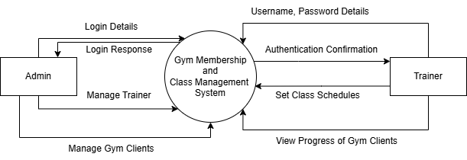
Fig 3.5: Context Level Diagram of Gym Membership and Class Management System

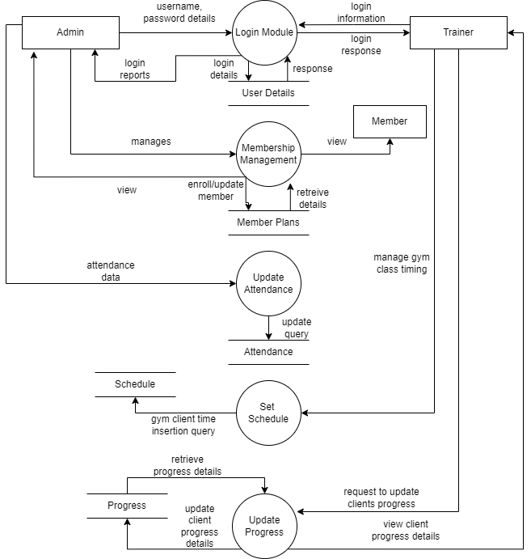
Fig 3.6: DFD Level 0 of Gym Membership and Class Management System

3.2 System Design
The Gym Membership and Class Management System (GMCS) was designed to ensure efficiency, scalability, and ease of use for both gym administrators and members. This section outlines the system’s architecture, database schema, user interface design, and data flow representation.

3.2.1 Architectural Design
The system follows a three-tier architecture, which consists of:
- Presentation Layer (Front-End)
  - The user interface (UI) is developed using Java Swing, providing an interactive environment for trainers and administrators.
  - Users interact with forms, tables, and buttons to perform various tasks such as signing up, booking classes, and tracking progress.
- Business Logic Layer (Back-End)
  - The business logic handles authentication, scheduling, membership management, and payments.
  - The system processes data validation and transaction handling.
- Data Storage Layer (Database)
  - The database is designed in MySQL, storing all relevant data, including member profiles, trainer schedules, payments, attendance records, and fitness progress.
  - Queries are optimized to ensure fast data retrieval and smooth performance.
System Components:
- Users: Trainers and administrators.
- Application Server: Handles requests, authentication, and data processing.
- Database Server: Stores and manages all data securely.
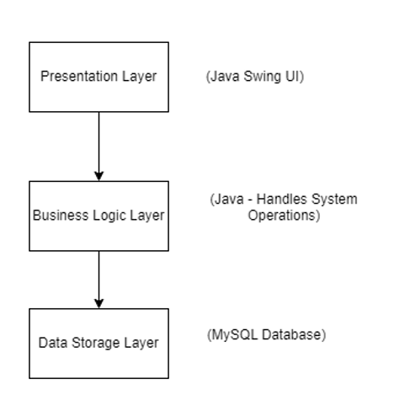
Fig 3.7: Architecture Design of Gym Membership and Class Management System

3.2.2 Database Schema Design

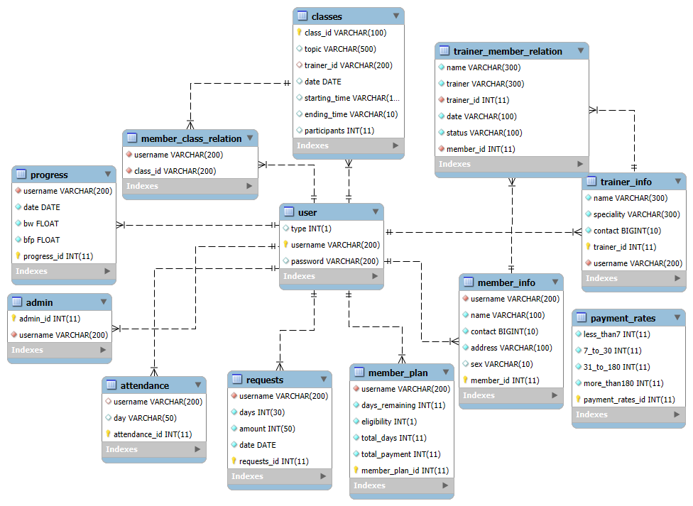
Fig 3.8: Architecture Design of Gym Membership and Class Management System

3.2.3 Interface Design
The user interface (UI) is designed to provide user-friendly experience for gym members, trainers, and administrators.
The Gym Membership and Class Management System consists of several key UI components structured for efficient navigation and user interaction. Below is an overview of the system’s interface design:

1. Login Page
- The system's entry point is where users (Admins, Trainers, and Members) authenticate themselves.
- Ensures secure access to respective dashboards.

2. Admin Dashboard
- Central hub for Admin Users to manage gym operations.
- Navigation options include:
  - Manage Attendance: Track and update attendance records.
  - Account Management:
    - Account Creation: Register new members and trainers.
    - View Accounts: Manage and update user accounts.
  - Payment Management:
    - Payment Rates: Update and adjust membership fees.

3. Trainer Dashboard
- Interface specifically designed for Trainers to manage their clients and schedules.
- Key Features:
  - View Clients: See a list of assigned clients.
  - View Client Requests: Check new requests from potential or existing clients.
  - Update Account: Modify personal or professional details.
  - View Attendance: Monitor client attendance and training session records.
  - Update Class Schedule: Adjust and update class timings.

UI Flow and Structure
- Users start at the Login Page and are directed to their respective dashboards based on role (Admin or Trainer).
- Admins manage accounts, payments, and attendance through their dashboard.
- Trainers handle clients, requests, and scheduling through their dedicated dashboard.
- The system provides structured navigation to ensure efficient gym membership, attendance tracking, and training session management.
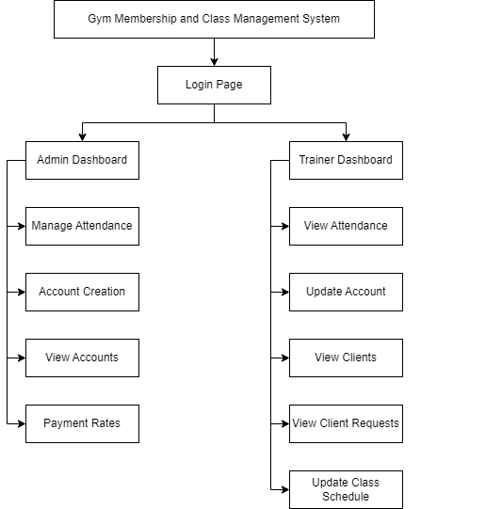
Fig 3.9: Overall System Interface of Gym Membership and Class Management System

3.2.2 Physical DFD
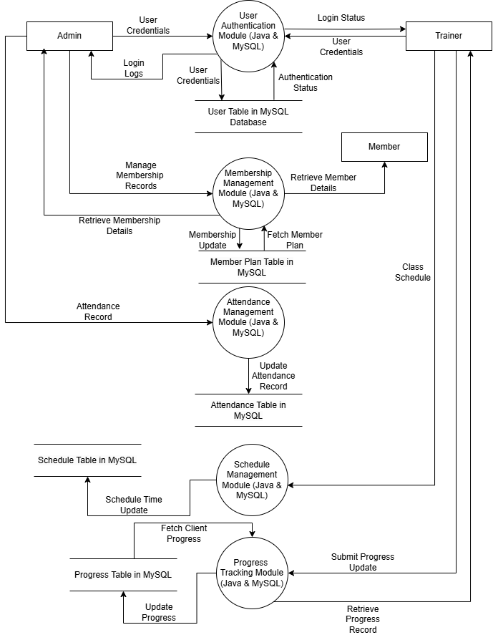 Fig 3.10: Physical DFD Level 0 of Gym Membership and Class Management System

Chapter 4: Implementation and Testing

4.1 Implementation:

4.1.1 Tools Used
JAVA: Java is a high-level, robust, object-oriented, and secure programming language used to develop the core functionality of the application.
VS Code: Visual Studio Code is a lightweight, powerful code editor with features like debugging, code completion, and extensions, used for writing and managing Java code for the project.
XAMPP: XAMPP is a free and open-source cross-platform web server solution stack package that includes Apache, MySQL, and PHP. It is used for managing the MySQL database and serving the backend of the application during development.
MySQL: MySQL is an open-source relational database management system (RDBMS) used to store and manage data for the gym management system.
Draw.io: Draw.io is a web application which helps to create different diagrams easily and effectively. The Use Case diagram, ER diagram, DFDs and Database Schema presented in this report to illustrate the functionality of the project are made using this website.

4.1.2 Implementation details of modules
Admin Views Attendance
The admin to marks and tracks member attendance using Swing. The first section allows the admin to enter a username and mark a member as present, validating the input against a database. If the member is already marked, an alert is shown. The second section displays a table of today's attendees, retrieved from the database. A back button lets the admin return to the dashboard. The program ensures real-time validation and updates attendance records dynamically.

Admin Creates Accounts
The admin creates Trainer and Member accounts. The interface has two panels—one for trainer accounts and another for member accounts. Users enter a username and password (for trainers only), and the system validates the inputs. The trainer's password must meet complex requirements (uppercase, lowercase, special character, and number). The system checks if the username already exists in the database before creating an account. If valid, the user is registered, and members are redirected to their dashboard.
Admin View User Accounts
The admin manages gym members account consisting of two main panels. The first panel allows the admin to search for a member by username. If the entered username is found in the database, the "View" button turns green, allowing redirection to the member's dashboard. If the username is invalid, the button turns red, preventing access. The second panel displays the full name of the searched user and a dynamically updating table that lists accounts matching the search input. The table data is retrieved from a database and updates as the admin types in the search field. The program ensures real-time validation and interaction with the database, enabling seamless member management.
Admin Updates Payment Rates
The admin updates gym membership payment rates through a GUI featuring a main panel that displays the current rates for various membership durations, including 1-6 days, 7-30 days, 30-180 days, and 180+ days. These rates are fetched from a database and displayed in text fields, allowing admins to modify them. The program ensures real-time validation of user input, each field accepts only numeric values, and the "Update Rates" button dynamically changes color based on input validity. If all values are valid, the button turns green, allowing the admin to submit changes. When clicked, the new rates are saved to the database, and the page refreshes to reflect the updates. This program enables efficient membership rate management while maintaining a user-friendly and error-free experience.

Member View Attendance
Members can access their own attendance records, including dates.
Member Manages Account
Here the user retrieves existing member details from a database and allows users to update their name, address, phone number, and gender. The program checks if the entered details are valid, such as ensuring the name includes a full name format, the phone number has ten digits, and an address is provided. If all inputs are correct, the update button turns green and saves the changes to the database; otherwise, error messages guide the user. The interface also displays the member's total payment. The program ensures data accuracy and prevents redundant updates by checking if the new information is the same as the existing data.
Member Manges/Updates Their Gym Plan
Here the user views their current plan, extend their membership by selecting the number of days they want, and see the cost based on predefined rates. The interface consists of three main sections: the current plan display, a section for extending the plan, and a table showing recently added plan requests. Users enter the number of days they want to extend, and the program calculates the cost dynamically. If the input is valid, the "Request Plan" button turns green, allowing the user to submit the request. The program interacts with a database (DB class) to fetch and update membership details.
Trainer view attendance
Trainers can access their own attendance records, including dates.
Trainer Registration
Trainers can update their name, contact number, specialty, password into the system by providing respective details. Once updated, their information can be viewed by admins.
Trainer View Clients
Trainers can access a list of gym members assigned to them, including their names and contact details.

Trainer Manage Schedule
Trainers can set training sessions scheduled. They can also view their assigned members and delete sessions if needed
Trainer View Currently Pending Requests
Trainers can view the trainer requests sent by members and either accept or reject them.
Trainer View Member Progress
Trainers can track member progress, including body weight and body fat percentage. This data helps with customizing training plans.
Trainer View Member Profile
Trainers can view the information of including name, contact number, sex.
Admin Book Member Class
Admin can book classes or sessions scheduled by trainers while also being able to view the class details like starting time, ending time, date and total participants.
Admin Manage Member Trainer
Members can view the list of trainers and send requests to them, while also being able to view their profile information like name, contact number and specialty.
Admin Manage Member Progress
Admins can view and update members’ progress with member’s body weight and body fat percentage. The body weight and body fat percentage of the member can also be compared with the statistics of two dates.

4.2 Testing:
Testing is a crucial process in software development that ensures the system functions as intended and meets the requirements. It goes beyond debugging and encompasses quality assurance, validation, verification, reliability, and availability checks. Testing can be performed at various levels to ensure that all components of the system operate effectively and efficiently.

4.2.1 Test Cases for Unit Testing
Unit testing is the phase where individual components or modules of the system are tested to verify that they function correctly. In the context of this desktop application, unit tests were carried out to check the core functionalities such as user login, membership management, progress tracking, and database interactions. Each function was tested independently to ensure proper behavior.
Table 4.1 Login Functionality Test Cases
SN | Action | Input | Expected Outcomes | Actual Outcomes | Test Results
1 | Launch Application | Run Java | Login Frame Displayed | Login Frame Displayed | Pass
2 | Submit Empty Username & Password | Username: (empty), Password: (empty) | "Invalid Username" message | "Invalid Username" message | Pass
3 | Enter Valid Username & Password | Username: "trainer", Password: "Trainer123!" | Redirect to Dashboard | Redirect to Dashboard | Pass
4 | Enter Invalid Password | Username: "ipsit", Password: "12345" | "Invalid Password" message | "Invalid Password" message | Pass

Table 4.2 Member Dashboard Viewing Test Cases
SN | Action | Input | Expected Outcomes | Actual Outcomes | Test Results
1 | View | Username: "ipsit" | Member Dashboard Displayed | Member Dashboard Displayed | Pass
2 | View | Username: "invalid" | "Invalid Username" message | "Invalid Username" message | Pass

Table 4.3: Get Trainer Test Cases
SN | Action | Input | Expected Outcomes | Actual Outcomes | Test Results
1 | Send Request | Username | Request sent to Trainer | Request sent to Trainer | Pass
2 | View Profile | Username | Profile Information Displayed | Profile Information Displayed | Pass
3 | Cancel Request with Pending Status | Request Status: "Pending" | Redirect to Dashboard | Redirect to Dashboard | Pass

Table 4.4 User Management Test Cases
SN | Action | Input | Expected Outcomes | Actual Outcomes | Test Results
1 | Send Request | Username | Request sent to Trainer | Request sent to Trainer | Pass
2 | View Profile | Username | Profile Information Displayed | Profile Information Displayed | Pass
3 | Cancel Request with Pending Status | Request Status: "Pending" | Redirect to Dashboard | Redirect to Dashboard | Pass

Table 4.5 Progress Tracking Test Cases
SN | Action | Input | Expected Outcomes | Actual Outcomes | Test Results
1 | Update | Body Weight: Invalid | Update button turns red | Update button turns red | Pass
2 | Update | Body Weight: 55 kgs and Body Fat %: 12 | Data Inserted into Table | Data Inserted into Table | Pass
3 | Compare | Date with no recorded data | Update button turns red | Compare button turns red | Pass

4.2.2 Test Cases for System Testing
System testing involves verifying the integration of all system components. It ensures that all modules work together correctly in the real-world environment. In this case, system testing was conducted after integrating key components such as the login system, membership management, progress tracking, and data persistence using the database.

Table 4.6 Test Cases For System Testing
SN | Action | Input | Expected Outcomes | Actual Outcomes | Test Results
1 | Launch Application | Run Java | Login Frame Displayed | Login Frame Displayed | Pass
2 | Login with Correct Credentials | Username: "john", Password: "12345John!" | Redirect to Dashboard | Redirect to Dashboard | Pass
3 | Add New Trainer | Username: "john", Password: "12345Dewy!" | Message: “Trainer account has been successfully created!” | Message: “Trainer account has been successfully created!” | Pass
4 | Extend Member Membership | Create Plan with 5 Days | Membership is extended | Membership is extended | Pass
5 | Update Rates | 1-6 Days: 200,  7-30 Days: 150 | Rate is updated | Rate is updated | Pass

Chapter 5: Conclusion

5.1. Lesson Learnt / Outcome
The development of the Gym Membership and Class Management System (GMCS) provided valuable insights into software development, project management, and user experience design. Some of the key lessons learned include:
- Understanding User Requirements: Conducting thorough research and interacting with potential users helped us design a system that meets the needs of gym administrators, trainers, and members.
- Importance of Security: Handling user data and payments requires robust security mechanisms, including password validation and access control.
- Database Optimization: Efficient database management was crucial in handling large amounts of membership, attendance, and scheduling data without performance degradation.
- Software Development Lifecycle (SDLC): Implementing the waterfall model ensured a systematic approach from research and design to development, testing, and debugging.
- User Experience (UX) Considerations: A well-designed UI is essential for enhancing user engagement and reducing onboarding time for gym members and administrators.
- Error Handling & Testing: Comprehensive unit testing and system testing played a vital role in improving system reliability and reducing potential issues after deployment.
Overall, the project strengthened our ability to develop real-world applications, improved our problem-solving skills, and provided hands-on experience in full-stack development and database management.

5.2. Conclusion

The Gym Membership and Class Management System successfully addresses key challenges in managing gym operations, offering a streamlined and automated solution for membership registration, scheduling, attendance tracking, and progress monitoring. By replacing manual and paper-based processes, the system enhances efficiency, accuracy, and overall user experience.

With features like membership management, class scheduling, trainer assignments, and payment handling, the system simplifies the workload for administrators while providing an intuitive interface for gym members. The integration of security measures and validation mechanisms ensures data protection and system integrity.

In conclusion, GMCS represents a scalable, cost-effective, and user-friendly solution for modern fitness centers. The project demonstrates the successful application of software engineering principles to solve real-world operational challenges, paving the way for further innovations in gym management technology.

5.3. Future Recommendations

While GMCS provides significant improvements in gym management, there are several areas where enhancements can be made:
- Mobile Application Integration: Developing a mobile app for Android and iOS would enhance accessibility for gym members, allowing them to book classes, track progress, and make payments on the go.
- Personalized Workout & Diet Plans: Adding an option for trainers to create and recommend customized workout and nutrition plans for members based on their fitness goals.
- Biometric Authentication: Integrating fingerprint or facial recognition for secure member check-ins and attendance tracking.
- Automated Payment Reminders & Subscription Renewals: Enhancing the system with automated email/SMS reminders for upcoming membership renewals and failed payments.
- Integration with Wearable Devices: Connecting with fitness trackers (e.g., Fitbit, Apple Watch, or Google Fit) to monitor members' workouts and sync progress data with their gym profiles.
- Multilingual Support: Expanding the system to support multiple languages, making it more accessible for diverse gym communities.
- Cloud-Based Deployment: Migrating to a cloud-based architecture to improve scalability and allow gym chains to manage multiple branches under one centralized system.
By implementing these recommendations, the GMCS can evolve into a comprehensive, AI-powered fitness management solution, further enhancing operational efficiency and user engagement in the fitness industry.

REFERENCES

[1] | [Online]. Available: https://www.gymmaster.com/.
[2] | Z. G. Management. [Online]. Available: https://www.zoho.com/creator/apps/gym-fitness-management-software.html.
[3] | Z. Planner. [Online]. Available: https://zenplanner.com/.
[4] | M. Software. [Online]. Available: https://www.mindbodyonline.com/.
[5] | J. G. J. V. Jafferey A. Hoffer, in Modern System Analysis and Design, 6 ed., Prentice Hall India.
[6] | L. B. Jeffery Whitten, in System Analysis and Design Methods, 7 ed., McGraw-Hill.

Appendix

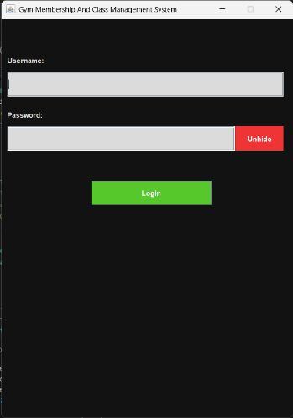
Login Screen
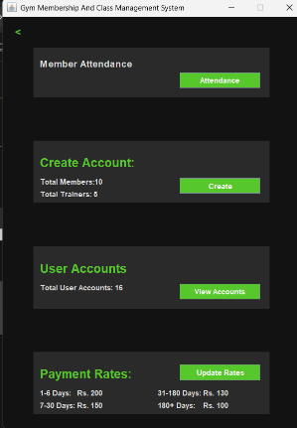
Admin Dashboard
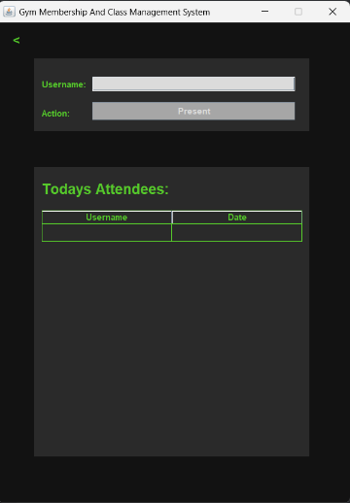
Attendance Table
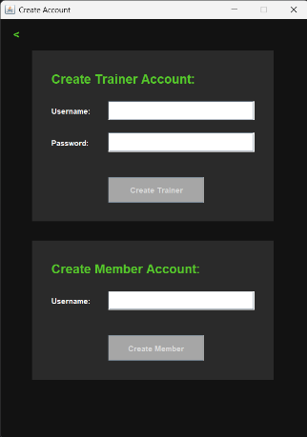
Account Creation
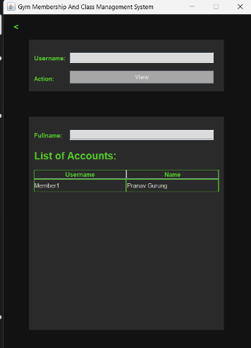
Account View
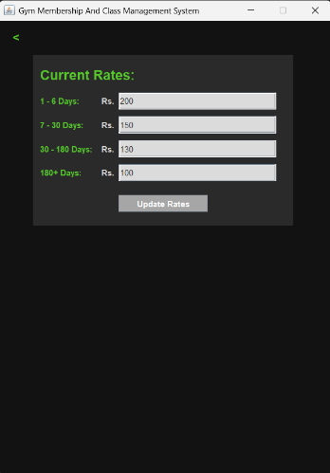
Payment Rates
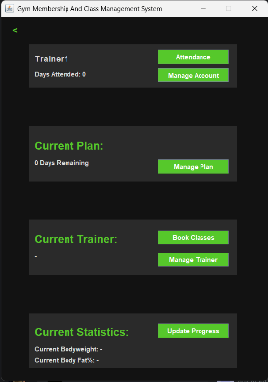
Trainer Dashboard
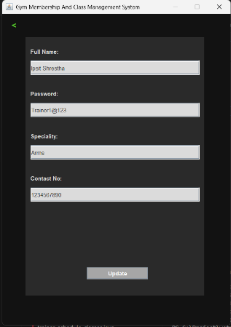
Trainer Information
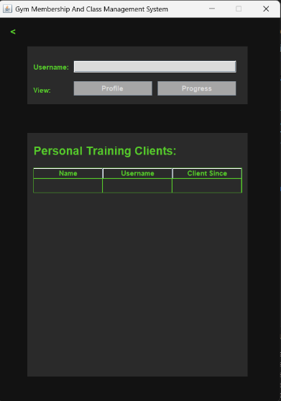
View Clients

